

**Supply Chain Analysis**

( A Power BI-based Diagnostic Report )

**Name** : Varun S

**ID-NO** : PTID-CDA-JUN-25-541

**Date** : 09-07-2025

**Supply Chain Analysis**

The supply Chain is the network of production and logistics involved in producing and delivering goods to customers. And Supply Chain Analysis means analyzing various components of a Supply Chain to understand how to improve the effectiveness of the Supply Chain to create more value for customers.

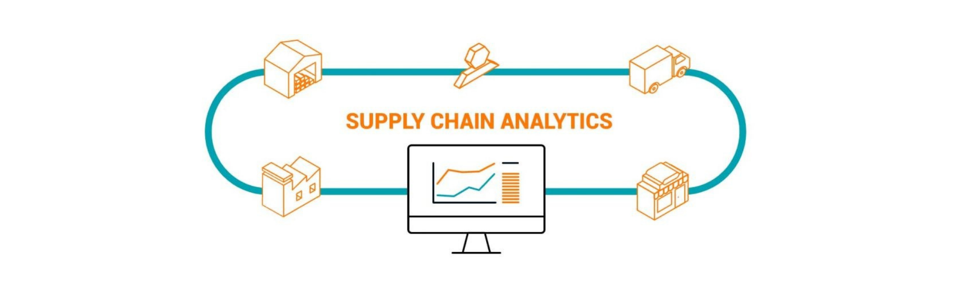

**Diagnostic Analytics**

Diagnostic Analytics goes beyond descriptive analytics by identifying the root causes of supply chain issues. By analyzing data from different sources, such as suppliers, logistics providers, and customers, organizations can identify the factors that contribute to delays, disruptions, or quality issues in their supply chain. This can help them take corrective actions to prevent similar problems from happening in the future.

**Executive Summary**

This report presents a detailed diagnostic analysis of a Lakmē company’s supply chain using Power BI. It focuses on understanding product performance, supplier efficiency, shipping logistics, and operational costs using real-world business metrics. Key visual insights were built to drive data-driven decisions and improve supply chain performance.

**Project Objectives**

• Identify top-performing product categories and SKUs.

• Compare supplier costs and quality levels.

• Evaluate shipping carriers and transportation modes.

• Analyze stock levels and lead times to avoid overstock or delays.

**Tools & Technologies Used**

• Power BI – For visualization and interactive reporting and Dashboard

• Power Query – For cleaning and transforming data

• DAX – For calculated metrics

**Dataset Overview**

Here is a dataset I have collected from a My SQL server. The dataset is based on the supply chain of Makeup products. Below are all the features in the dataset:

* Product Type
* SKU
* Price
* Availability
* Number of products sold
* Revenue generated
* Customer demographics
* Stock levels
* Lead times
* Order quantities
* Shipping times
* Shipping carriers
* Shipping costs
* Supplier name
* Location
* Lead time
* Production volumes
* Manufacturing lead time
* Manufacturing costs
* Inspection results
* Defect rates
* Transportation modes
* Routes
* Costs

**Data Preparation**

During the data preparation phase, the following steps were carried out to ensure the dataset was clean, accurate, and analysis-ready:

**1. Data Cleaning**

• Duplicate and Error Removal: All duplicate records were identified and removed to avoid skewed analysis. Common data entry errors were corrected for consistency.

• Data Type Validation: Ensured that:

• Numeric values (e.g., cost, price, quantity sold) were stored in proper numerical format.

• Categorical values (e.g., product type, supplier name) were stored as text.

• Currency fields (e.g., price, revenue) were formatted as currency data types.

**2. Error Correction**

• Revenue Correction: It was observed that the original “Revenue Generated” column contained incorrect values. To fix this:

• A new Revenue Generated column was calculated using the formula:

**Revenue = Price × Number of Products Sold**

• This newly calculated column was used for further analysis and visualization.

**3. New Column Creation**

To enhance the depth of analysis, the following additional columns were created:

• Revenue per Unit:

**Revenue per Unit = Revenue Generated ÷ Number of Products Sold**

• Total Cost:

**Total Cost = Manufacturing Cost + Shipping Cost + Route Cost**

These transformations and new metrics played a critical role in building accurate visualizations and deriving actionable business insights.

**KPIs and Measures**

|  |  |  |
| --- | --- | --- |
| MEASURE | DAX Formula | Purpose |
| Total Revenue | SUM(supply_chain_table[Revenue_generated]) | Total money earned from product sales |
| Total Product Sold | Sum(supply_chain_table[Number_of_products_sold]) | Total sales volume |
| Total Cost | Sum(supply_chain_table[Total Cost]) | Sum of manufacturing + shipping costs |
| Profit | [Total_Revenue]-[Total_Cost] | Business profitability |
| Avg. Lead Time | Average(supply_chain_table[Lead_times]) | Delivery performance |
| Avg. Defect Rate | AVERAGE(supply_chain_table[Defect_rates]) | Supplier product quality |

**Visualizations and Dashboard Insights**

**Executive Summary**

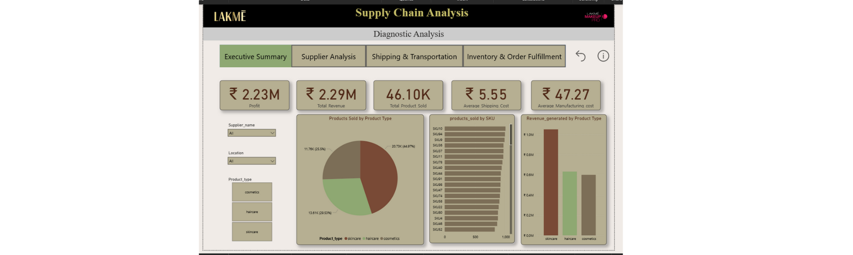

**Visuals Used:**

• KPI Cards show Total Revenue, Total Products Sold, and Profit.

• Pie Chart displays Revenue by Product Type.

• Column chart shows SKUs by Products Sold.

• Clustered Bar Chart compares Revenue across Product Types.

• Slicers allow filtering by Product Type and Supplier Name.

**Supplier Analysis**

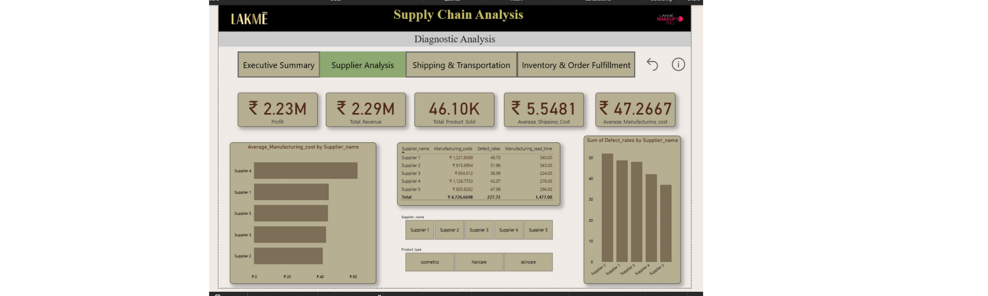

**Visuals Used:**

• Matrix: Displays Supplier Name, Manufacturing Costs, Defect Rates, and Manufacturing Lead Time.

• Bar Chart: Shows Average Manufacturing Cost by Supplier for easy cost comparison.

• Stacked Column Chart: Visualizes Defect Rate by Supplier to identify quality issues.

• KPI Card: Highlights the Average Manufacturing Cost across all suppliers.

• Slicer: Filter the report by Supplier Name to focus on specific vendors.

**Shipping & Transportation**

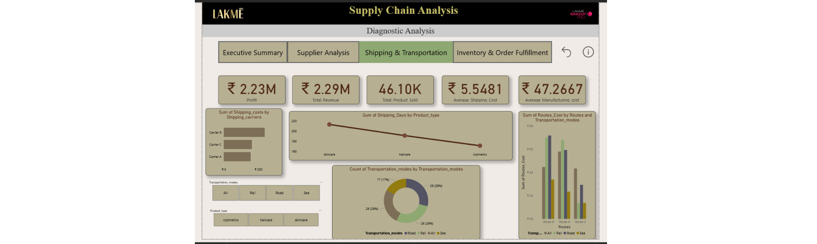

**Visuals Used:**

• Bar Chart: Compares Shipping Carriers by Average Shipping Costs, helping identify cost-efficient carriers.

• Donut Chart: Displays Usage Count by Transportation Mode.

• Clustered Column Chart: Shows Route-wise Shipping Costs, helping assess high-cost routes.

• Line Chart : Tracks Shipping Times by Product Type over time for delivery efficiency analysis.

• Slicer: Use Transportation Mode to filter visuals and analyze specific modes

**Inventory and Fulfillment**

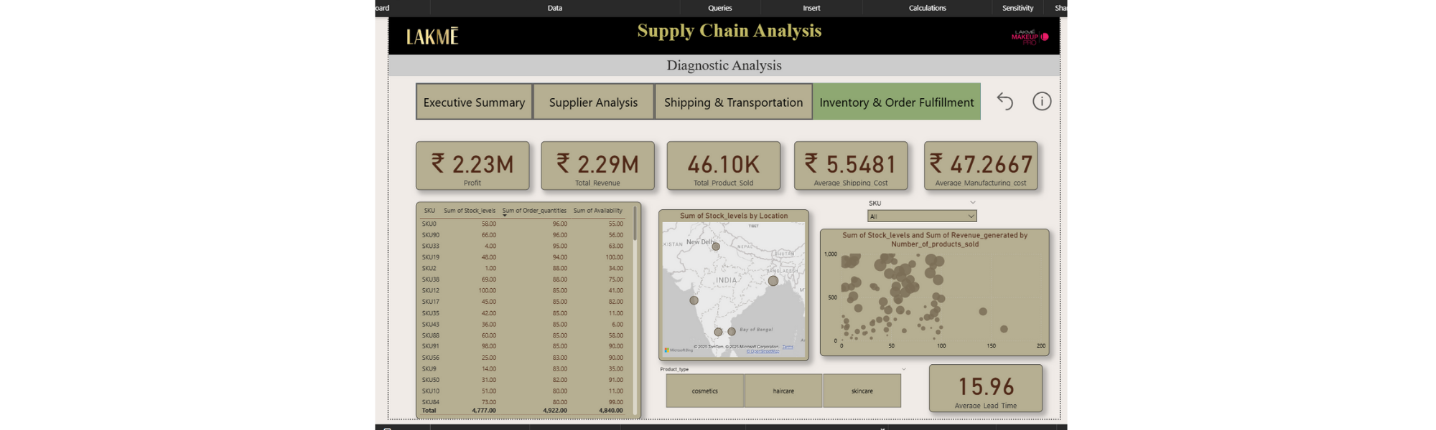

**Visuals Used:**

• Table: Displays SKU, Stock Levels, Order Quantities, and Availability to monitor inventory status.

• Scatter Chart: Plots Stock Levels vs Products Sold, with Revenue as bubble size — useful for spotting overstocked or underperforming items.

• Card: Shows the Average Lead Time to fulfill orders.

• Slicer: Filter the data by SKU or Product Type for focused analysis.

**Supply Chain Analysis**



**Interactivity and Slicers**

Mention the use of slicers:

• Product Type

• Supplier Name

• Shipping Carrier

• Transportation Mode

Users can filter visuals interactively to explore specific segments of the supply chain

**Insights**

• Skincare generated the highest revenue.

• SKU10 was the best-selling item.

• Supplier 1 had the lowest cost and defect rate.

• Supplier 4 was the most expensive.

• Carrier B had the lowest shipping cost.

• Sea transport is cheapest; air is most expensive.

• Several SKUs were overstocked with low sales.

• Fulfillment lead time averages 17 days.

**Recommendations**

Give actionable recommendations based on the dashboard:

• Focus marketing on skincare products

• Shift to Supplier 1 for cost savings and better quality

• Reduce use of air shipping to cut logistics costs

• Monitor SKUs with high inventory and low sales

**Conclusion**

Wrap up the report by highlighting the value of your insights:

The diagnostic analysis built in Power BI highlights critical inefficiencies and opportunities in the company’s supply chain. The interactive dashboard enables real-time filtering, deeper insights, and strategic decision-making to optimize inventory, reduce costs, and boost revenue.

**Summary**

Supply Chain Analysis means analyzing various components of a Supply Chain to understand how to improve the effectiveness of the Supply Chain to create more value for customers.